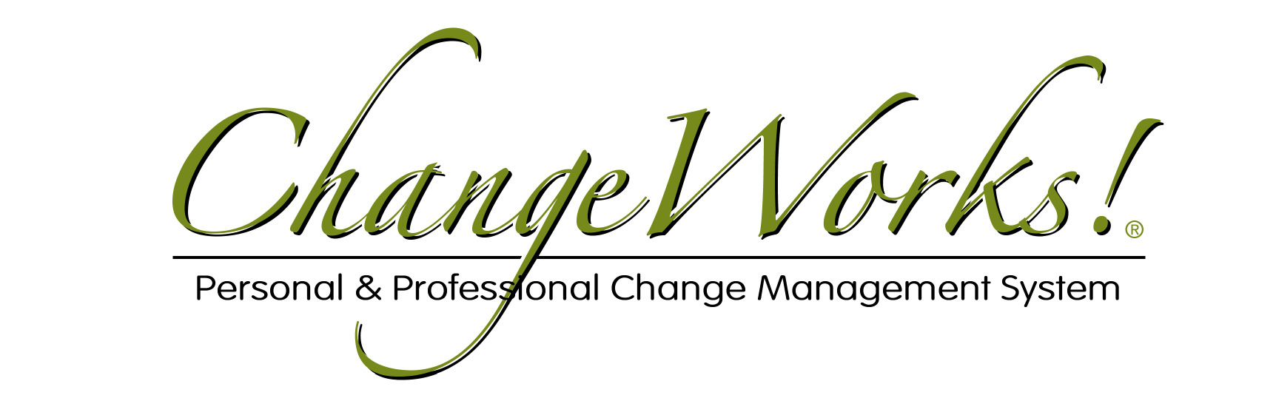

— Applying the ChangeWorks® System —
Implementation Notes for Group Projects

1) Setting the stage:

For clients who are unfamiliar with the ChangeWorks® System, help them understand where the ChangeGrid® fits into their personal change process and what the tool is intended to do —

Are your employees as productive as you need them to be?

It’s an amazingly challenging time for businesses — and it’s likely to stay this way for a long while to come. Today, more than ever, managers and business owners are faced with a daunting task — fighting an uphill battle to compete …and survive. Most companies have already “tightened their belts” and now have to rebuild with a smaller team, fewer resources, tougher conditions and higher expectations.

To make that happen, they simply must get the most from whatever resources they have.

A business’s most valuable assets are its employees. Companies have heavily invested in attracting the most talented people for their enterprises and providing those employees with training and development that turns their talents into profits.

When times get tough and resources get tight, managers must focus on getting maximum performance from each of their team members.

In all likelihood your team members KNOW what needs to be done and they KNOW exactly how to do it, which sounds like the perfect setting for unbridled success. The question is, are they doing it?

Managers need to know on a continuous basis just how engaged their team members are — and they have to know the right things to do to boost engagement and ensure execution.

The ChangeGrid predicts the likelihood of an employee actually DOING what needs to be done WITHOUT any outside support or guidance — and if outside support or guidance is needed, the ChangeGrid indicates the form that support or guidance must take.

Obviously, this becomes an extremely valuable tool in the hands of a manager or business owner.

You may also suggest that your client view the videos found at http://www.masterstream.com/cws for more information —

“The Nature of Change” presents the core concepts of the ChangeWorks® System.

“The Merging of Brilliance” explores some of the historical and scientific principles from which the ChangeWorks® System evolved.

“Completing a ChangeGrid®” provides an orientation to the use of the tool.

2) Setting expectations:

Next, review some or all of the following key points, based on how well your client currently understands the ChangeWorks® System —

The ChangeGrid® is not a personality test and works in perfect harmony with ALL popular psychometric tools.

The ChangeGrid® is client-driven and activity-specific. The entire focus is on the client’s unique current and desired situations — and the mission-critical activities associated with making the changes they have in mind.

The ChangeGrid® provides insight, a framework for discussion and an action planning tool.

While it may look complicated to the uninitiated, the ChangeGrid® is actually quite simple.

3) Developing the Activity List

The ChangeWorks® process itself begins by accessing the ChangeWorks® System online. After logging in, initiate a Group ChangeGrid® for your client and begin constructing their unique Activity List. Here are some things to keep in mind:

Any situation or set of situations can be the subject of the ChangeGrid®.

Any activity can be explored on the ChangeGrid®, but for maximum value, the focus should be placed on creating a comprehensive list of “mission-critical” activities related to those situation(s).

The activities MUST be shared by all members of the population chosen for the survey.

Activities can be identified in countless ways, including: psychometric test results, job or task analyses, project requirements, strategic planning sessions, formal intake interviews and simple, spontaneous conversations.

Creating an Activity List is an organic process and is driven by the client. Whenever possible, use the client’s actual words — the intention is for the client to own the activities listed.

All activities must begin with an actionable verb – usually something the employees would physically do.

If the client finds it challenging to pinpoint mission-critical activities and you have extensive experience working with clients in similar situations, you may want to share with them lists of activities other clients have used to get them thinking — but DON’T let the client simply lift a ChangeGrid® full of activities from the lists. It’s always a good practice to compile comprehensive sets of activities for assistance purposes, as well as for conducting industry studies, research projects, marketing programs, client screening and intake sessions.

A ChangeGrid® can cover up to 50 unique activities — and leaning towards more activities does produce a superior debriefing session.

Here is a screenshot of a sample Activity List, designed for a Transition Team, ready for one of the team members to complete —

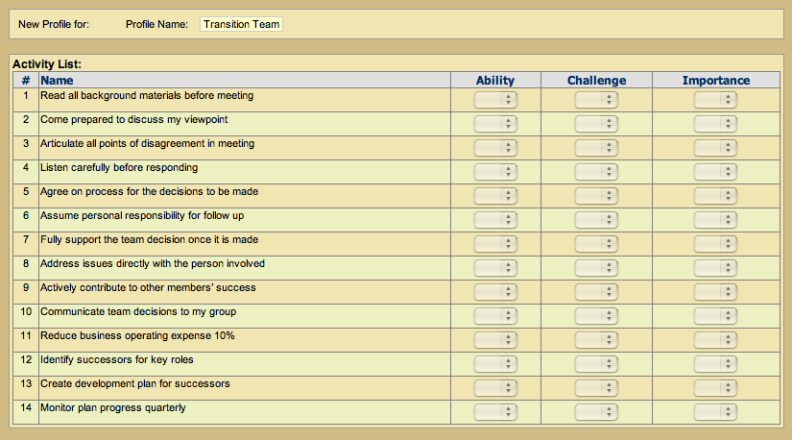

4) Administering the ChangeGrid®

Once the Activity List has been created, the ChangeGrid® is ready for your client’s chosen population to complete. This can be accomplished most easily via emailed invitations containing a link to the profile. You may want to share a few pointers with your client:

The System asks respondents to provide numerical answers to three questions regarding their perceptions of each of the activities the client has included on their list.

The three dimensions are Perceived Ability, Perceived Challenge and Perceived Importance — and are reported on a low-to-high scale of 0 to 12.

Encourage respondents to give each question serious thought and answer as honestly as possible.

If a question arises about perception vs reality, remember that people generally operate based on their personal perceptions of things, regardless if those perceptions are right or wrong. Besides, more often than not, “reality” is just a mislabeled set of an outsider’s perceptions. Unless there is irrefutable proof – it’s ALL perception.

The ChangeGrid® can be best thought of as a mirror reflecting the conversation the respondents are having with themselves about the situations and specific activities the client has chosen to explore. To convey the idea to the client more simply, say: “Your ChangeGrid enables me to SEE a conversation that YOUR EMPLOYEES are having with THEMSELVES about THEMSELVES. It will tell me which of the activities they’re likely to follow-through on with no assistance whatsoever — and pinpoints activities that are problematic.”

The accuracy, expediency and bottom-line value of a ChangeGrid® experience is directly related to the respondents’ willingness to be honest.

Here is a screenshot of the Transition Team sample Activity List with a respondent’s answers filled in —

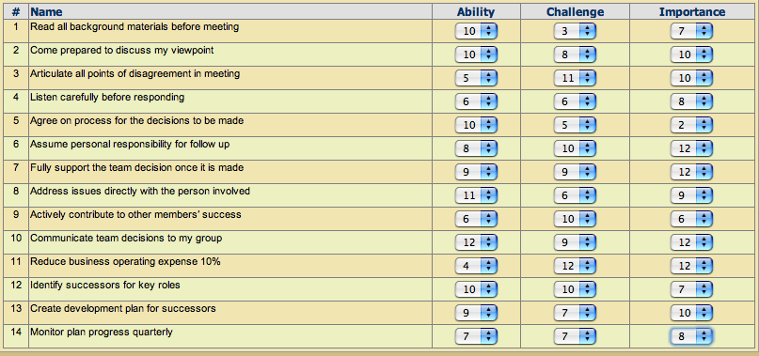
5) Debriefing the ChangeGrid®

Once all members of the chosen population have completed the ChangeGrid®, it is ready for viewing and debriefing.

A Group ChangeGrid® report contains two types of ChangeGrids®: An individual ChangeGrid® for each respondent and an Activity ChangeGrid® reflecting how all of the respondents view each specific activity.

Here is a screenshot of a sample Individual ChangeGrid® —

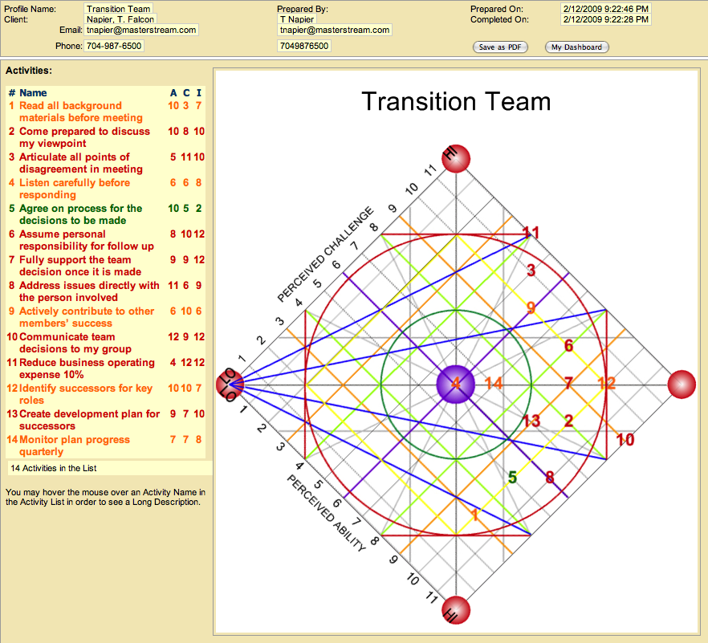

Use the Quick Reference Guides to help you add structure and richness to the reading. The majority of the insights you will share can be found on the two Quick Reference Guides for the Response States Summary and the Basic Adjective Map.

The Response States Summary provides key characteristics associated with each level of the 5 levels of productive tension.

The Basic Adjective Map offers a localized set of descriptors which offer additional insights and nuances.

Begin the debriefing following ChangeWorks’® only rule, “Pay Attention to Tension” — which translates into exploring the activities as they appear from the top of the ChangeGrid® to the bottom.

Follow the debriefing process to validate the plotting of each activity and obtain buy-in on the activities needing attention.

Related activities that cluster together can generally be discussed together.

You may also summarize the debriefing by offering general comments about activities plotting in some of the key areas of the ChangeGrid®.

Here is a screenshot of a sample Activity ChangeGrid® —

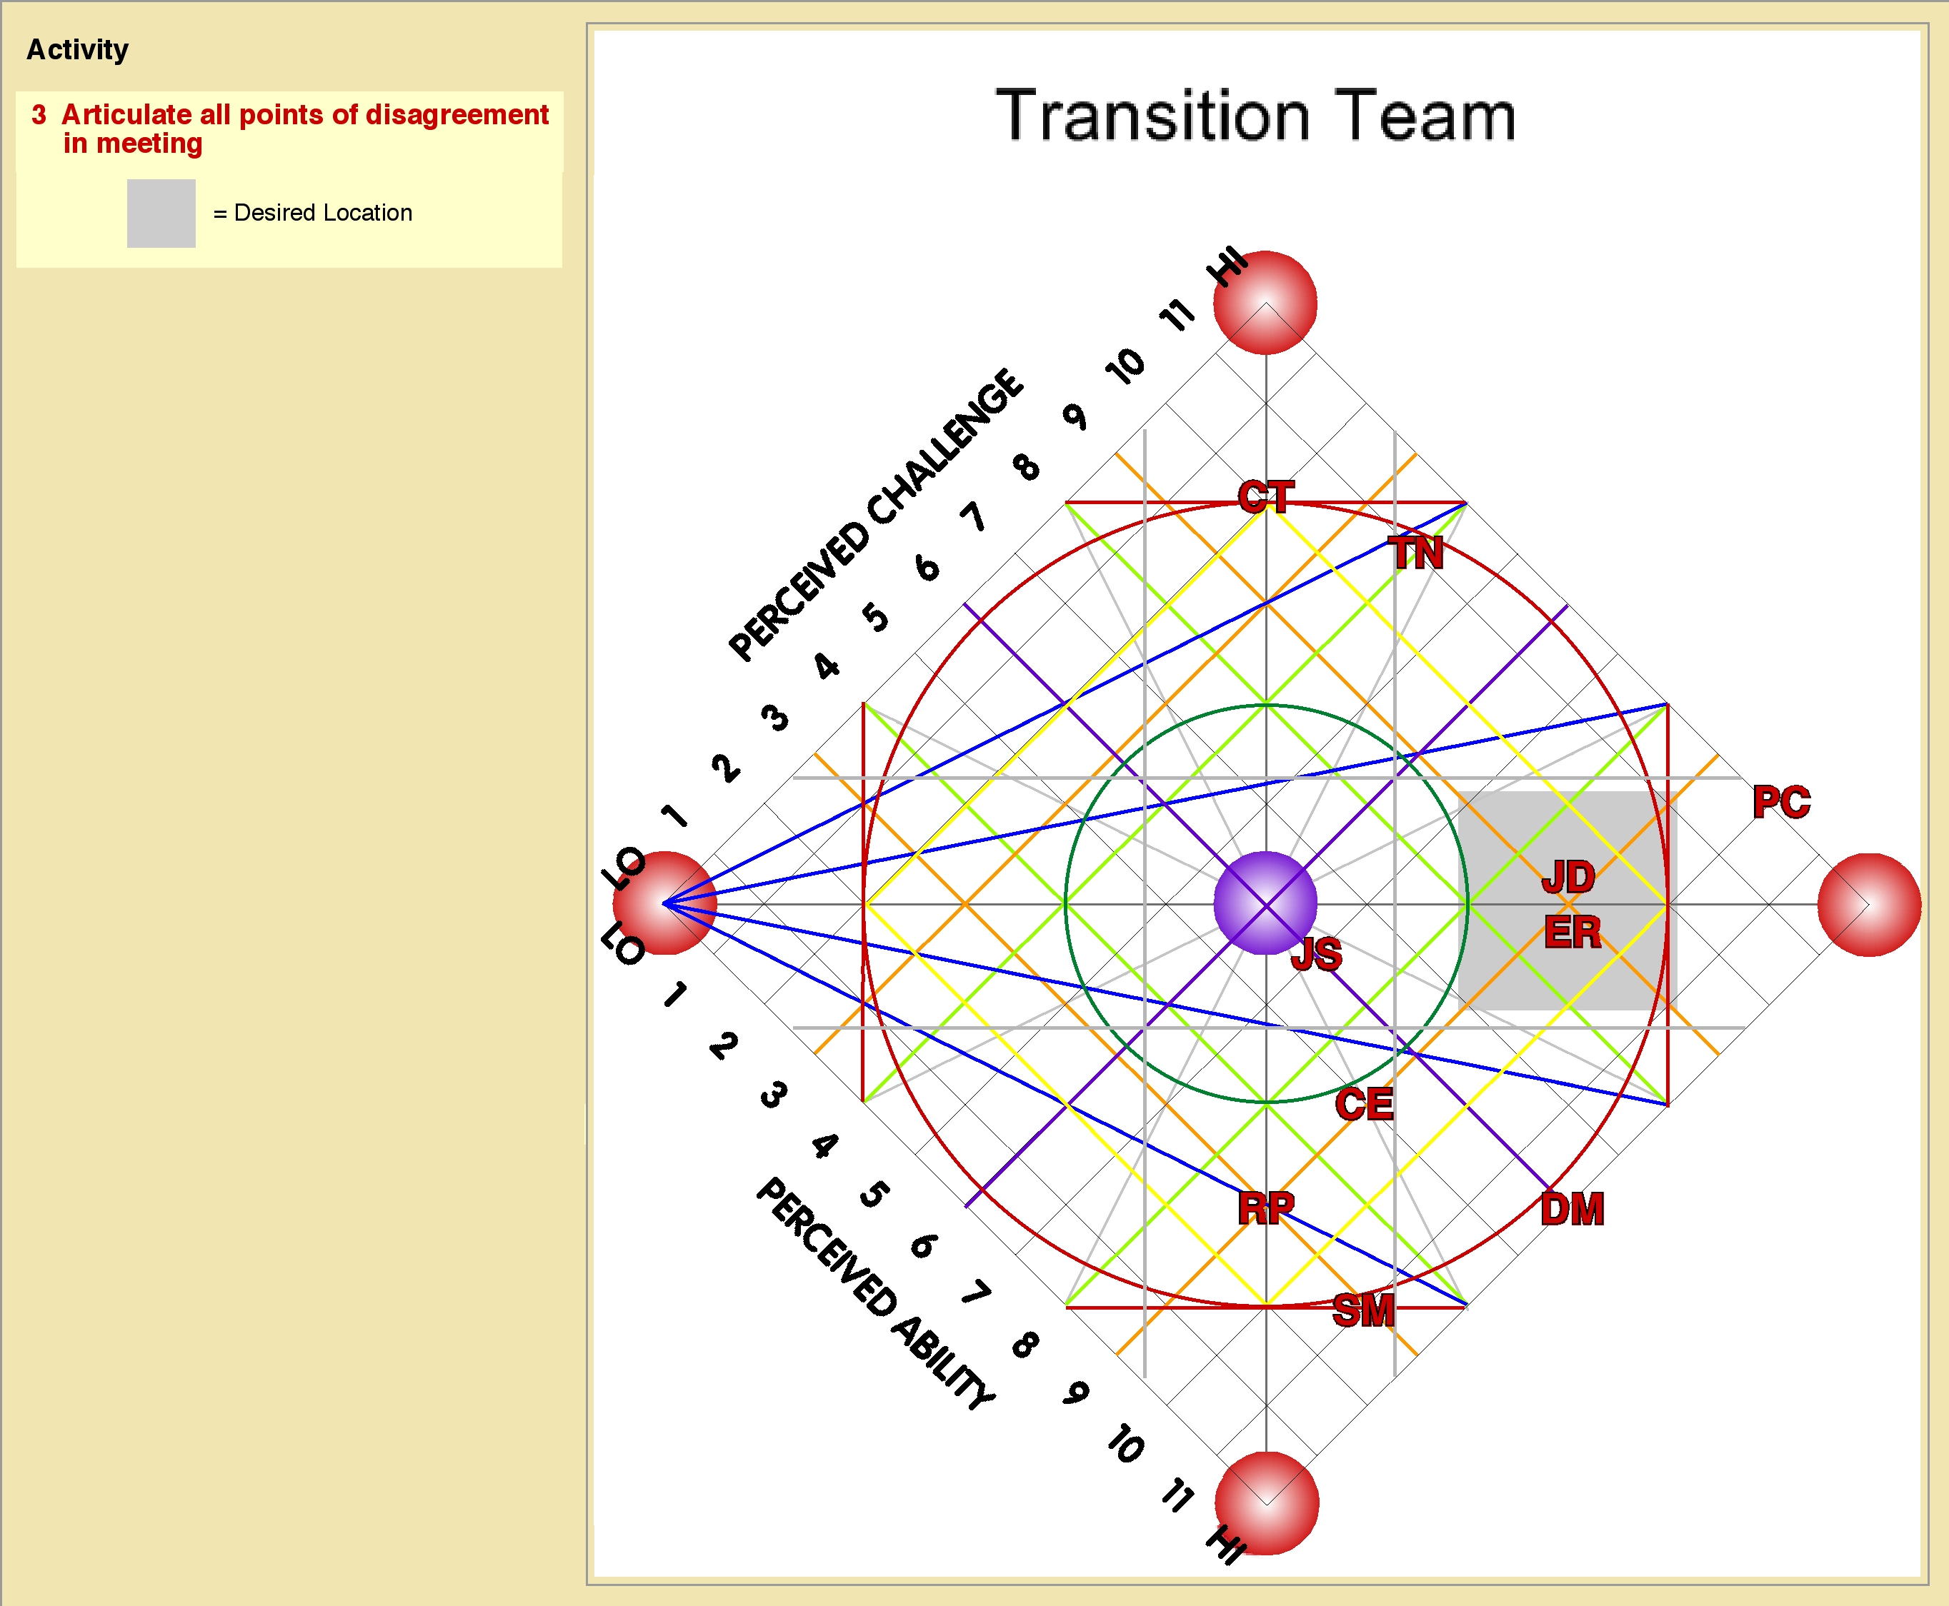

In addition to an Individual ChangeGrid® for each of the survey participants, the ChangeWorks® System also generates a ChangeGrid® for each of the activities the client has chosen to explore. The difference between the two types of ChangeGrids® is that an Individual ChangeGrid® reflects how a participant responds to the full set of activities, while an Activity ChangeGrid® reflects how ALL of the participants responded to a single activity.

Individual ChangeGrids® are intended to help the manager coach their team members one-on-one. Activity ChangeGrids® help the organization determine the best actions to take to have maximum positive impact on the entire group.

Individuals who plot further “DownGrid” than the desired location represent untapped potential and unrealized profits since their perceived ability greatly exceeds the level of challenge they associate with the activity. Those who plot “UpGrid” of the desired location see far greater challenge than their ability can handle and are lacking in the core knowledge, skill and experience the activity requires.

Activity ChangeGrids® allow the client to clearly see when the group as a whole would best benefit from either training, leadership, management or counseling initiatives.
Response States Summary:

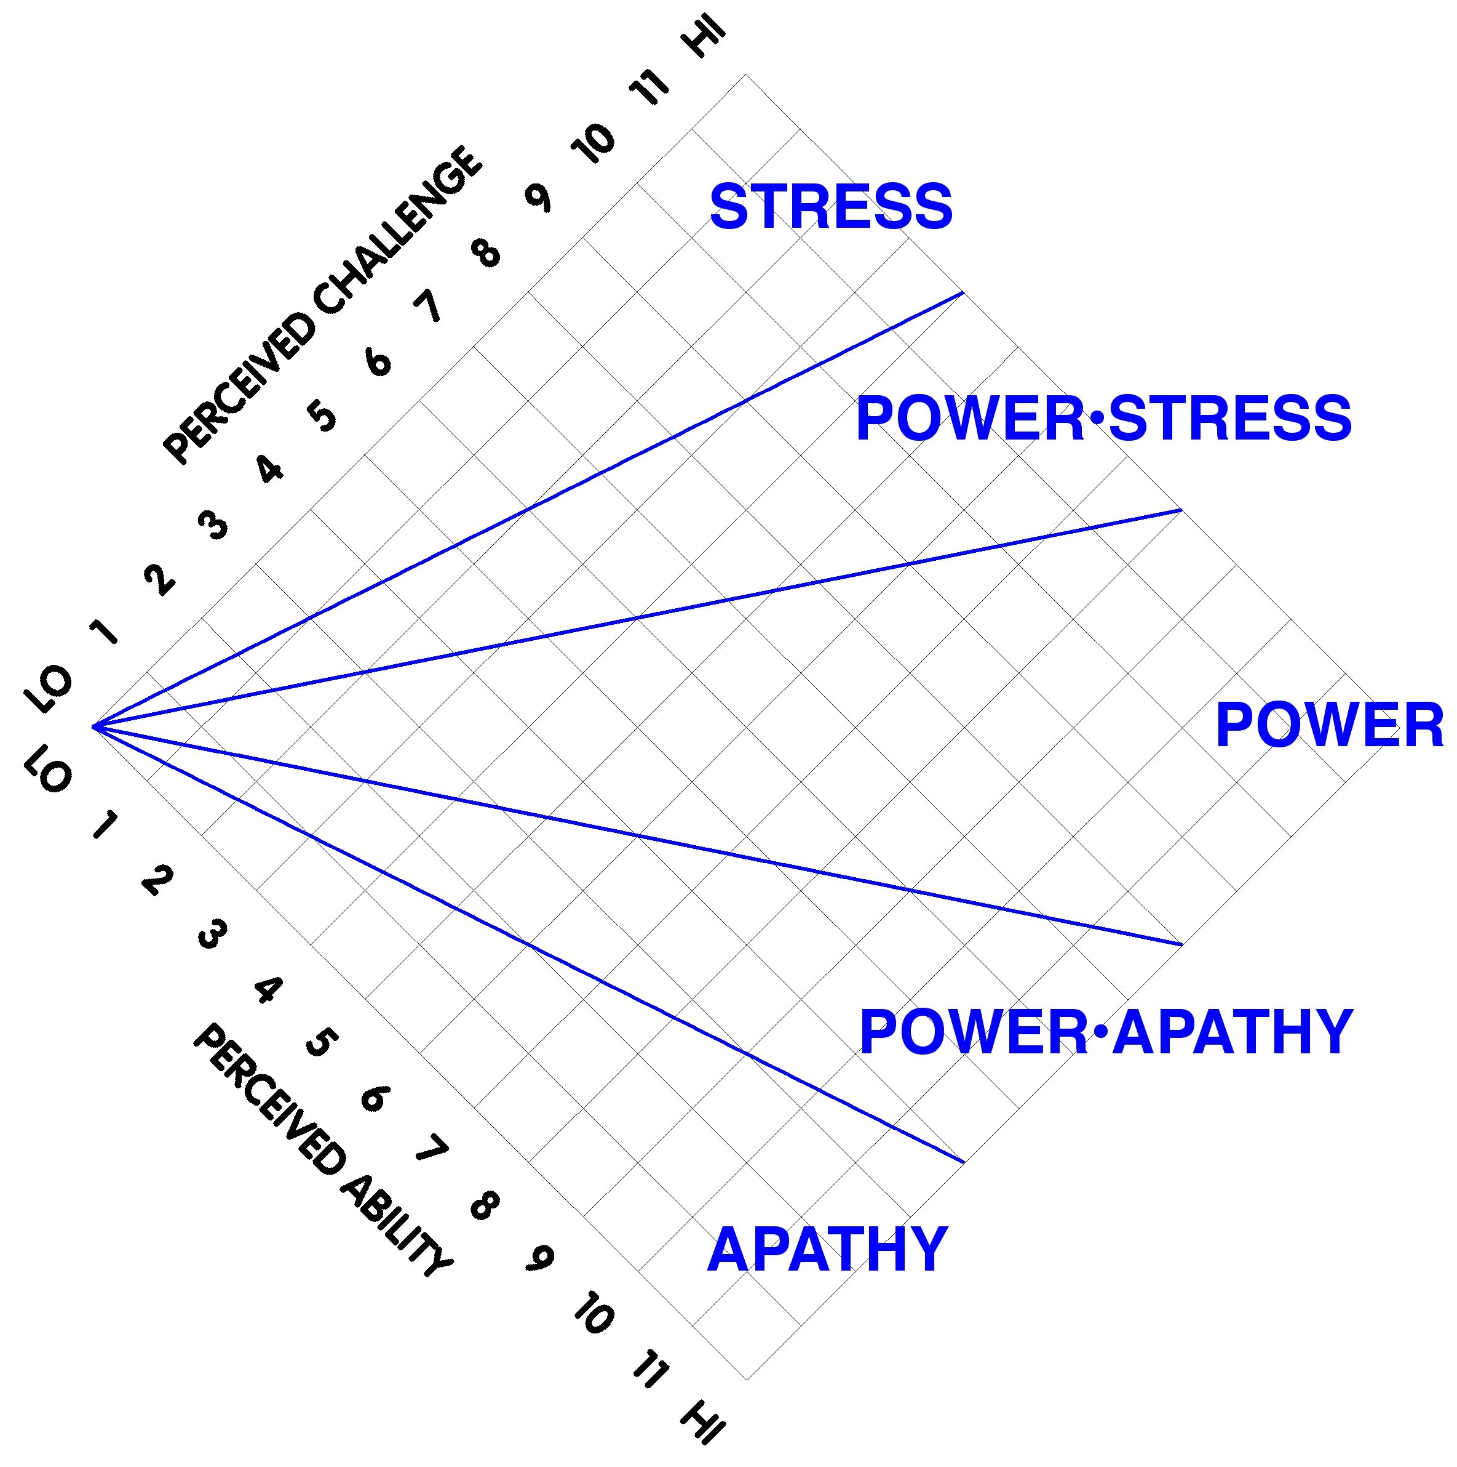

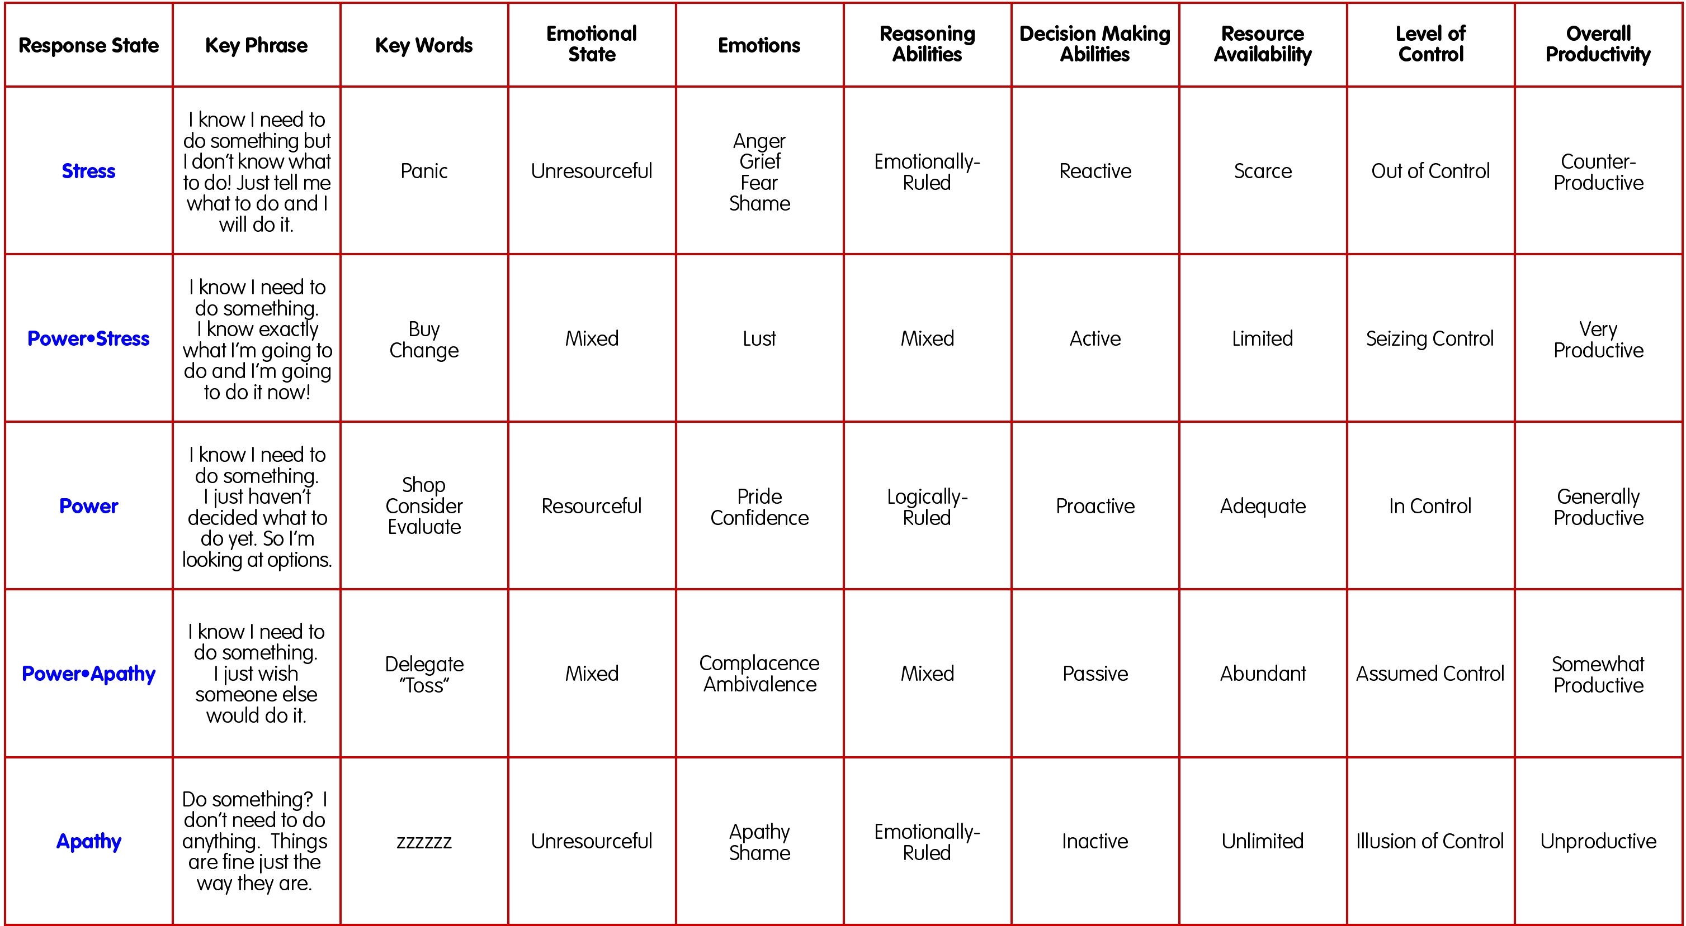

Basic Adjective Map:
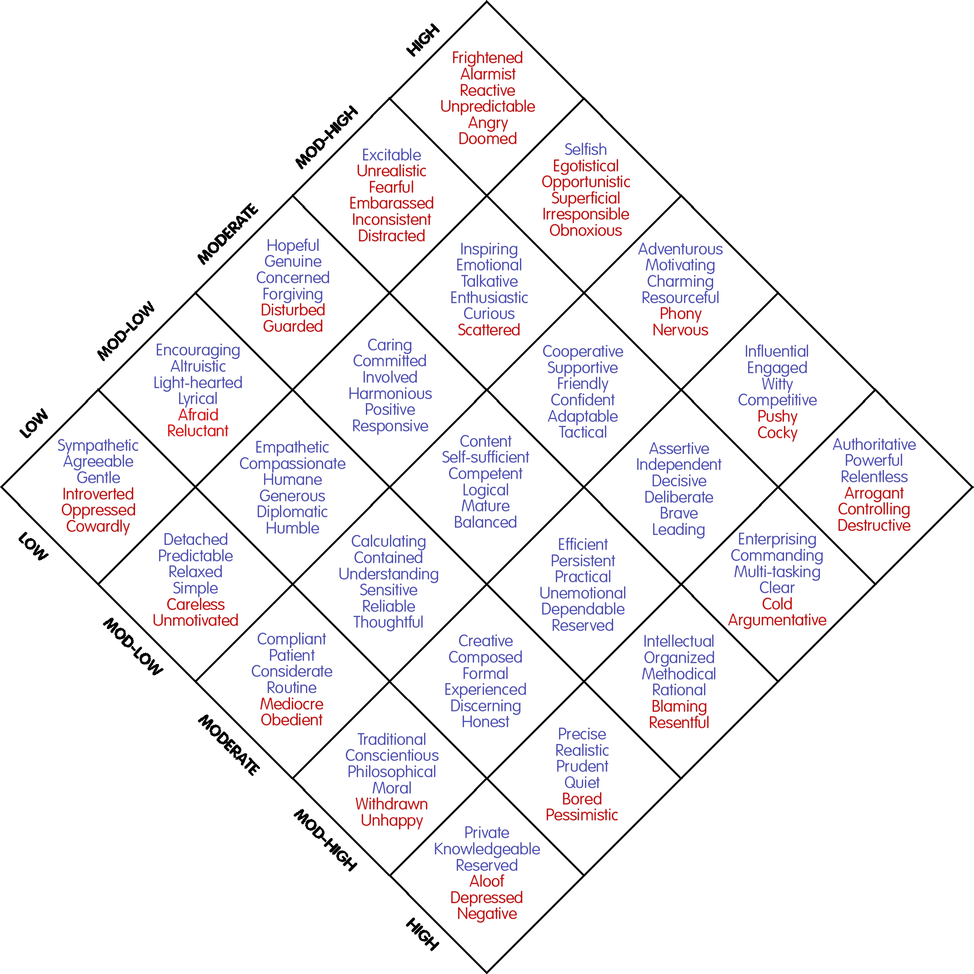

While there is no reason for you to share any of the Quick Reference Guides with your clients, if you choose to show them the Basic Adjective Map, here are a few important points to cover:

The Adjective Map should NEVER be confused with charts or diagrams associated with ANY psychometric tool. While there may be superficial similarities, the application and utilization is entirely different.

The ChangeGrid® does NOT attempt to describe the person — rather, focus is placed entirely on how clients are responding to the specific situations and activities they have chosen to explore. The adjectives are NOT characteristics of someone’s personality — instead, they describe the client’s mindset and behavior specific to a given activity in a given situation at a given moment in time.

The Basic Adjective Map offers a total of 150 unique descriptors — a mere fraction of those presented in the Comprehensive Adjective Map used by Certified ChangeWorks® Analysts.

For clients interested in the origins of the Adjective Map, refer them to the online video, “The Merging of Brilliance” or contact us directly to arrange for the client to participate in our “Comparative Human Typological Analysis” teleclass.

Summary Comments:
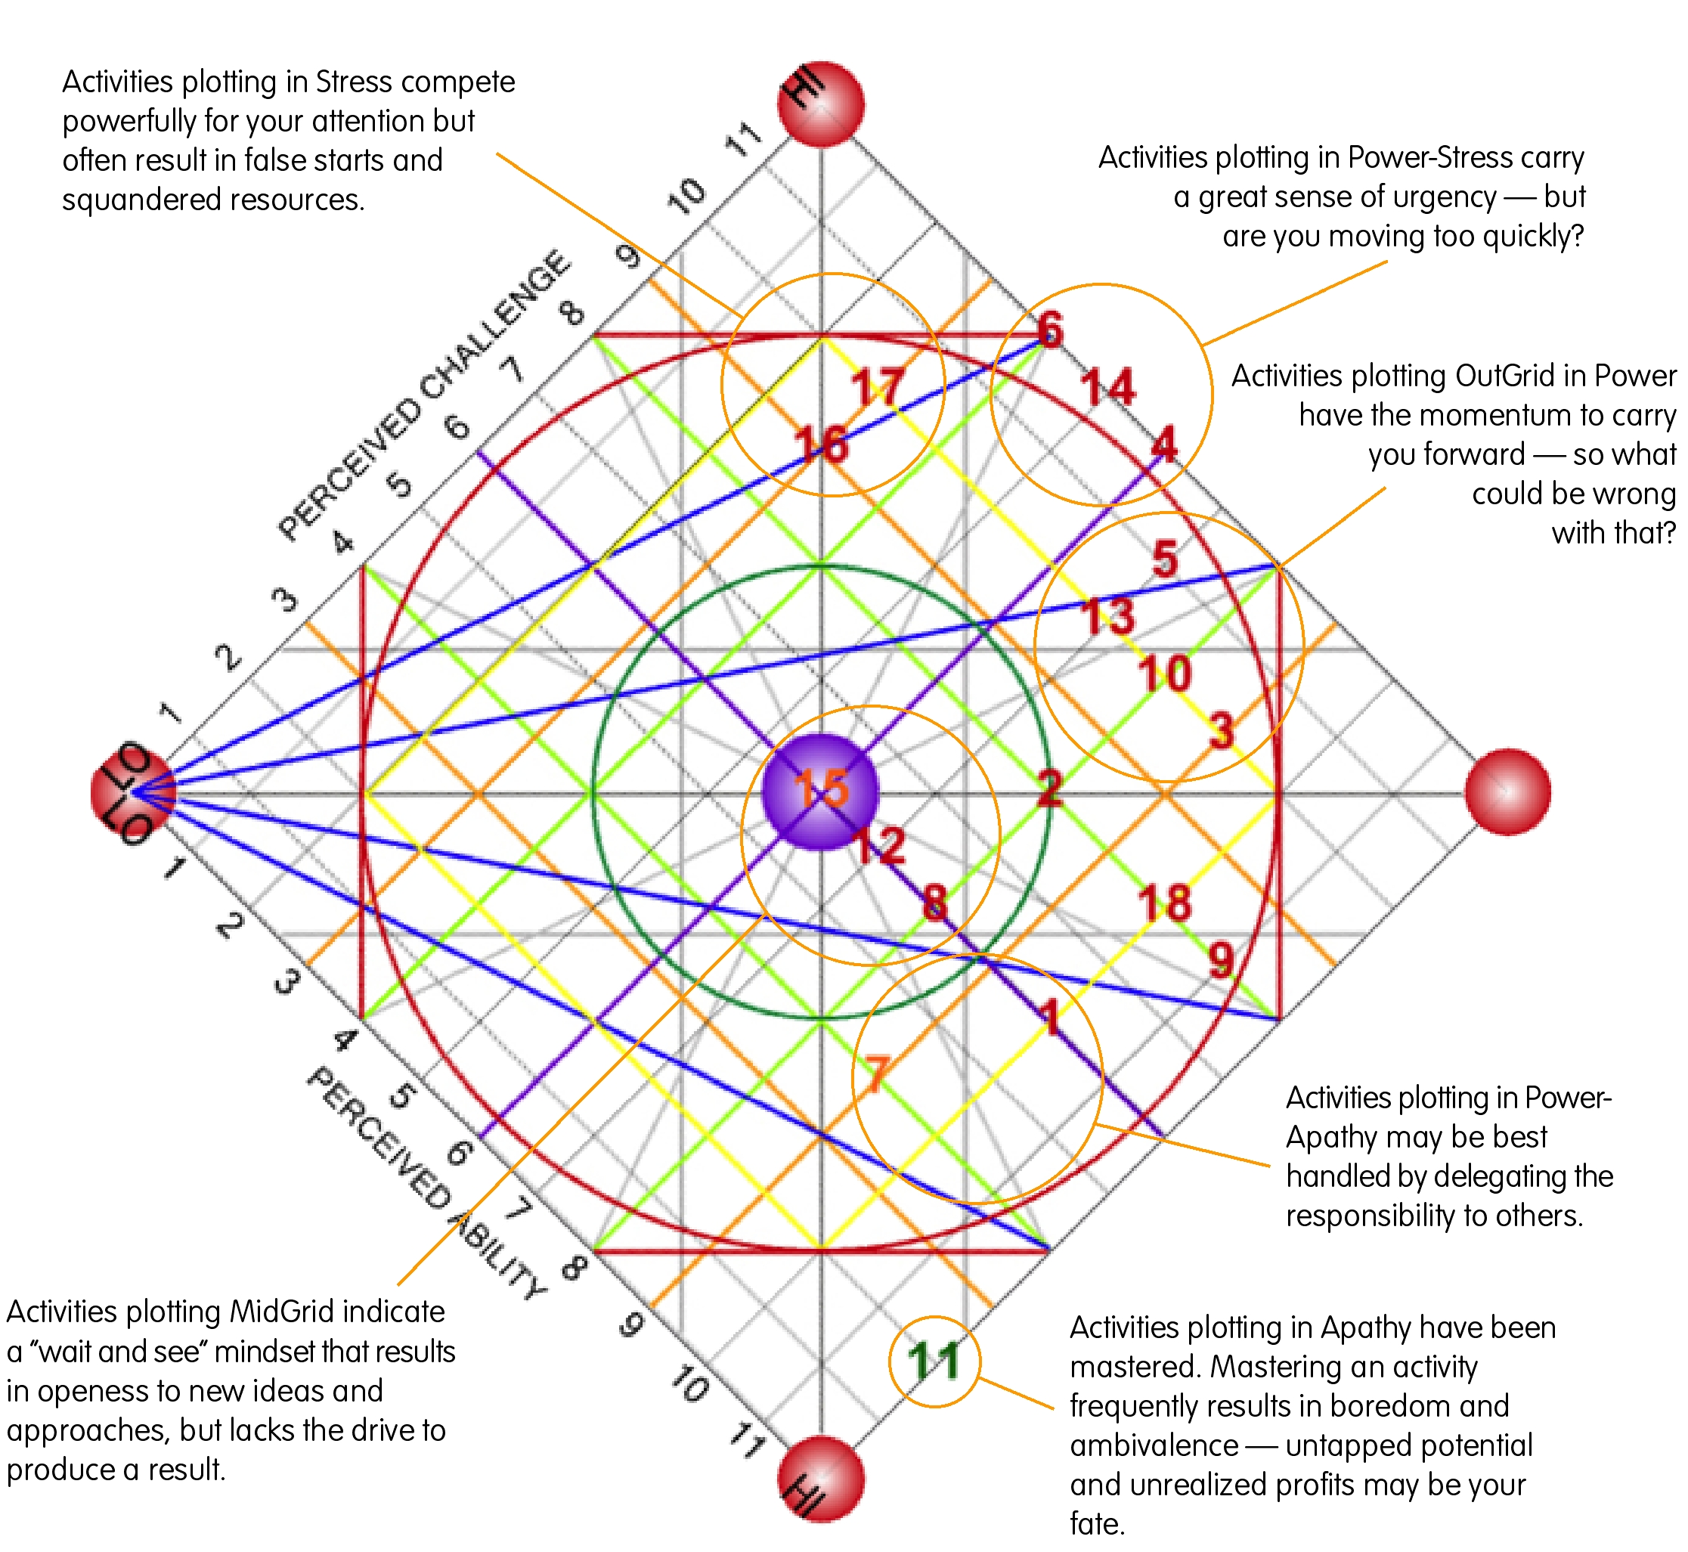

6) Developing Action Plans

As the debriefing process occurs, each activity will show itself to be in either a favorable or unfavorable location on the ChangeGrid®. An Action Plan should be created for each activity falling in an unfavorable spot. Here are some key points to cover:

The ChangeGrid® has 169 addressable locations, each of which is slightly different than those immediately adjacent to it — and drastically different than those at a distance. All locations have both a bright side and a dark side, so avoid all judgments about regions on the ChangeGrid® being “good” or “bad.”

There is no “perfect” location for “all” activities. The most desirable location is dictated by a number of factors, including: the activity itself, the timeframe for completing the activity and the client’s personal preferences.

Use the Basic Adjective Map as a tool to help you determine ideal locations for a given activity.

Develop an appropriate blend of ChangeGrid® Maneuvers — UpGrid, DownGrid, OutGrid & InGrid — to move the activity from its current position to its ideal position.

Encourage your client to use the online journaling feature to document their efforts on a daily basis. Journaling serves as a tool of accountability, develops self-discipline and keeps the coach informed.

Re-administer the ChangeWorks® profile at weekly, monthly or quarterly intervals (as you determine appropriate) to monitor progress and refine the Action Plans.

